*( Final term, summer 2019 )*

1. Difference between BJT and FET.

|  |  |  |
| --- | --- | --- |
| no | BJT | FET |
| 1 | **BJT** stands for Bipolar Junction Transistor. | **FET** stands for Field Effect Transistor. |
| 2 | BJT is the current controlled device. | FET is the voltage controlled device. |
| 3 | There are P-N-P and N-P-N type of BJT transistors. | There are P channel and N channel type of FET. |
| 4 | There are three terminals in a BJT device. emitter, base and collector. | There are three terminals in a FET device. source, drain and gate. |
| 5 | Its input impedance is low and output impedance is high. | It is a high input impedance device about 100 Mega Ohm and above |
| 6 | Noisy device due to presence of minority carriers. | It is a majority carrier device. |
| 7 | It is bipolar device as current flows due to both majority and minority carriers. | FET is a unipolar device. |
| 8 | Thermal stability is lesser due to leakage current or reverse saturation current. | FET provides greater thermal stability compare to BJT. |
| 9 | BJTs are applicable for low current applications. | FETS are applicable for low voltage applications. |
| 10 | BJTs have a higher max frequency and a higher cutoff frequency. | FETs have low to medium gain. |

1. Classification of FET.

FET is Voltage controlled device because its output characteristics are determined by field which depends on the voltage applied.

It has three terminals named as

·        Source (S)

·        Drain(D)

·        Gate(G)

classification of FET is given below:

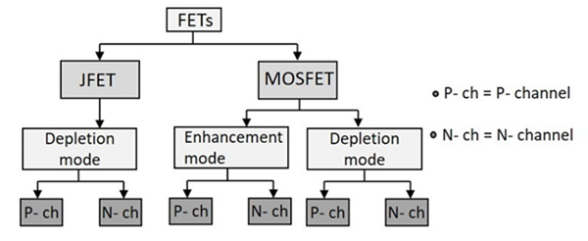

Here,   
JFET= Junction field effect transition (For e- flow).

MOSFET = Metal oxide semiconductor field effect transition (For hole flow).

N-ch= N channel.

P-ch= P channel.

3) Construction and working principle of n channel and p channel JFET.

### **Construction of JFET**

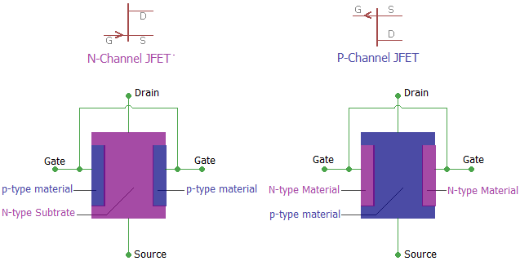

In the above image, we can see the basic construction of a JFET. The N-Channel JFET consists of P-type material in N-type substrate whereas N-type materials are used in the p-type substrate to form a P channel JFET.

JFET is constructed using the long channel of semiconductor material. Depending on the construction process, if the JFET contains a great number of positive charge carriers (refers as holes) is a P-type JFET, and if it has a large number of negative charge carriers (refers as electrons) is called N-type JFET.

### **Working of JFET**

One best example to understand the working of a JFET is to imagine the garden hose pipe. Suppose a garden hose is providing a water flow through it. If we squeeze the hose the water flow will be less and at a certain point if we squeeze it completely there will be zero water flow. JFET works exactly in that way. If we interchange the hose with a JFET and the water flow with a current and then construct the current-carrying channel, we could control the current flow.

When there is no voltage across gate and source, the channel becomes a smooth path which is wide open for electrons to flow. But the reverse thing happens when a voltage is applied between gate and source in reverse polarity, that makes the P-N junction reversed biased and makes the channel narrower by increasing the depletion layer and could put the JFET in cut-off or pinch off region.

In the below image we can see the **saturation mode and pinch off mode** and we will be able to understand the **depletion layer became wider and the current flow becomes less**.

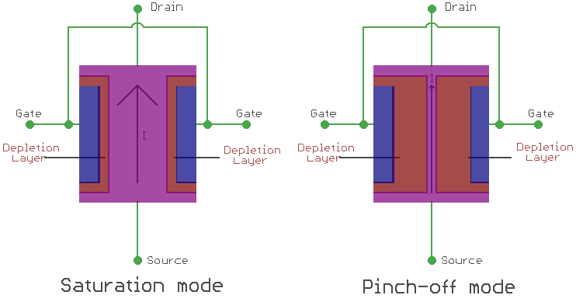

4) Define pinch off condition and pinch off voltage.

**If Vgs = 0 and Vds is further increased to a more positive voltage, then the depletion region touches each other and pinches off the n-channel. At that time Vds = Vp.**

**Then this condition is called pinch off condition. And the voltage that create this condition is called pinch off voltage.**

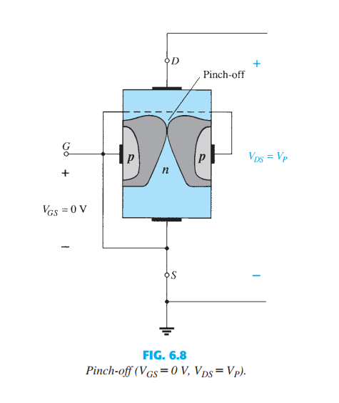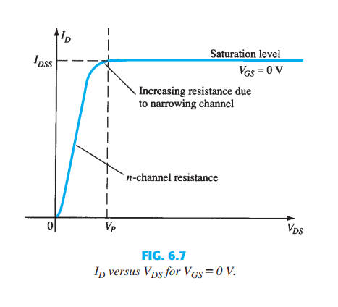

5) What will happen if drain to source voltage of an n-channel JFET is increased beyond pinch off voltage?

If we increase beyond of pinch off voltage, the drain current begins to saturate and it is termed Vd. Increasing the drain to source voltage beyond Vd The channel length decreases and the space charge region between the end of the channel and drain increases.

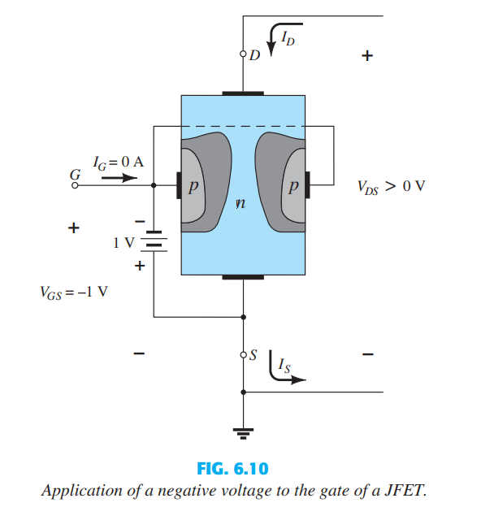

In Fig we can see a negative voltage of 1 V is applied between the gate and source terminals for a low level of VDS. The effect of the applied negative-bias VGS is to establish depletion regions similar to those obtained with VGS 0 V, but at lower levels of VDS. Therefore, the result of applying a negative bias to the gate is to reach the saturation level at a lower level of VDS, as shown in Fig for VGS = -1 V. The resulting saturation level for ID has been reduced and in fact will continue to decrease as VGS is made more and more negative. Note also in Fig how the pinch-off voltage continues to drop in a parabolic manner as VGSbecomes more and more negative

6) Characteristics of JFET.

The characteristics of JFET is defined by a plotting a curve between the drain current and drain-source voltage. The variation of drain current with respect to the voltage applied at drain-source terminals keeping the gate-source voltage constant is termed as its characteristics. Basically, the characteristics are of two types that are output characteristics or drain characteristics, and the another is transfer characteristics.

**Output Characteristics or Drain Characteristics:** In this case, as there is no voltage between gate and source terminal, thus, the drain current will flow from drain terminal to source terminal. It clearly implies that the channel width is more as the width of depletion layer will not vary initially because there is no external reverse biasing. This allows a large magnitude of current to flow through the channel.

**Terminologies involved in JFET characteristics**

1. **Knee Point:**  a point in the characteristics curve where the variation of drain current with drain-source voltage appears to be linear
2. **Pinch-off point:** The point in the curve above which the drain current does not increases further no matter how much we are increasing the drain to source voltage.
3. **Pinch-off Voltage:** The voltage at the pinch-off point is termed as pinch-off voltage.
4. **Drain-Source Saturation Current:** The drain to source saturation current is the current which becomes constant or completely enters a saturation state.

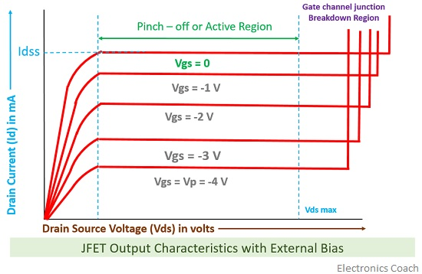

**Transfer Characteristics**

The transfer characteristics can be determined by observing different values of drain current with variation in gate-source voltage provided that the drain-source voltage should be constant. The transfer characteristics are just opposite to drain characteristics. The concept that in drain characteristics we are keeping the gate-source voltage constant and determining the values of drain current at different values of drain-source voltage while in transfer characteristics we are keeping the value of drain-source voltage constant. It can be easily observed that the value of drain current varies inversely with respect to gate-source voltage when the drain-source voltage is constant.

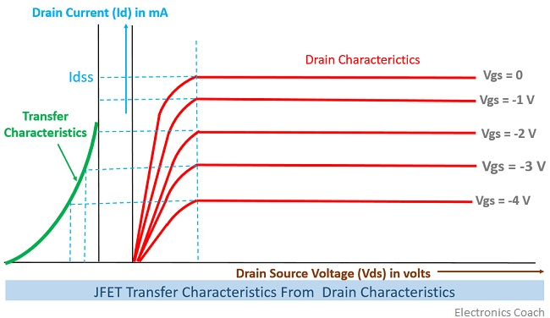

## 7) Construction and operations of n channel enhancement MOSFET.

## N- channel Enhancement type MOSFET:

The basic construction of the n-channel enhancement-type MOSFET is provided in the figure below. A slab of p-type material is formed from a silicon base and is again referred to as the substrate. The source and drain terminals are again connected through metallic contacts to n-doped regions, but note in the absence of a channel between the two n-doped regions. This is the primary difference between the construction of [depletion type MOSFET](http://www.electricalengineeringinfo.com/2016/11/MOSFET-types-of-MOSFET-construction-working-principle-of-depletion-type-MOSFET.html) and enhancement type MOSFET—the absence of a channel as a constructed component of the device.

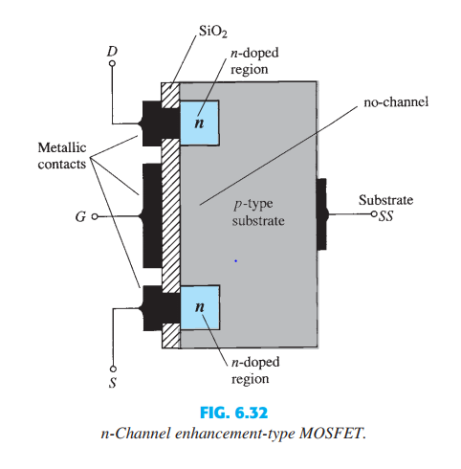

The SiO2 layer is present to isolate the gate metallic platform from the region between the drain and source, but now it is simply separated from a section of the p-type material. In summary, therefore, the construction of an enhancement-type MOSFET is quite similar to that of the depletion-type MOSFET, except for the absence of a channel between the drain and source terminals.

### **Operation of Enhancement type MOSFET:**

In Enhancement mode MOSFET the combination of Al metal contact, SiO2 layer, Semiconductor substrate act like a capacitor with silicon dioxide layer as dielectric. When a positive voltage is applied to the gate the bound charge displacement in SiO2 is as shown below. The electric field induced by external gate voltage repels the holes in p-type substrate adjacent to the silicon dioxide layer and the substrate will be depleted. Simultaneously it attracts the electrons in the N+ regions. As we continue to increase the gate to source voltage soon a n-type channel will be induced. The value of Vgs at which this happens is known. After the channel is induced if we apply small drain to source voltage electron current flows from source to drain through the induced N-channel. As we increase Vds continuously Ids also increase continuously. When Vds reaches Vds=Vgs-Vt the drain current reaches maximum and is in saturation. The channel at the drain end will be pinched off and further increase in the Vds will not have any effect on the drain current theoretically. But practically as Vds is increased further the pinch off end of the channel will move away from the drain towards the source.

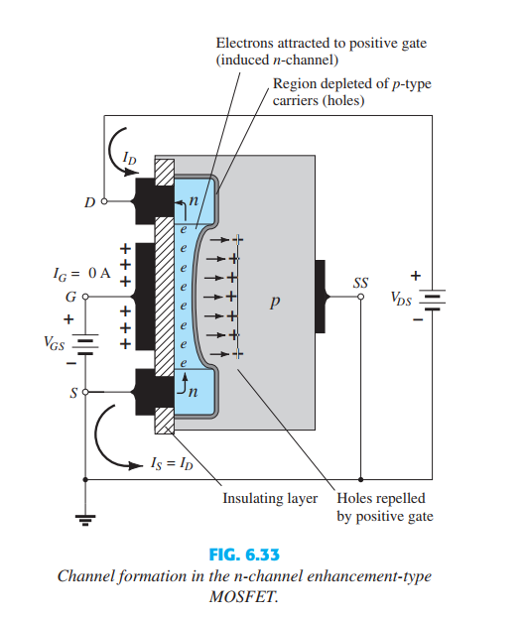

8) Construction and working principal of p channel and n channel depletion type of MOSFET.

## N – Channel Depletion MOSFET:

The **working principle of depletion MOSFET** is a little bit different from that of enhancement MOSFET. N – Channel Depletion MOSFET the substrate (body) is of [p-type semiconductor](https://www.electrical4u.com/p-type-semiconductor/). The source and drain regions are of the heavily doped [n-type semiconductor](https://www.electrical4u.com/n-type-semiconductor/). If we apply a potential difference between source and drain, a current starts flowing through the entire n region of the substrate.

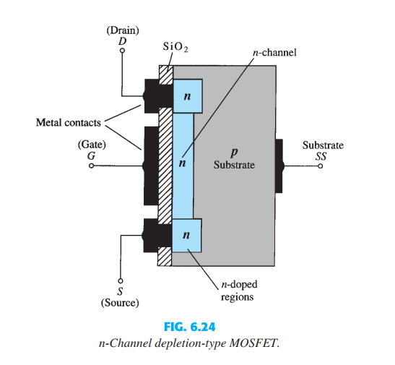

Now, let us apply a negative voltage at the gate terminal. Due to the capacitive effect, the free electrons get repealed and shifted downward in the n region just below the SiO2 dielectric layer. As a result, there will be layers of positive uncovered ions below the SiO2 dielectric layer. In this way, there will be a depletion of charge carriers occurred in the channel and hence the overall conductivity of the channel gets reduced. In this situation, for the same applied voltage at the drain, the drain current gets reduced. Here we have seen that we can control the drain current by varying depletion of charge carriers in the channel and hence we call it as depletion MOSFET.

## P – Channel Depletion MOSFET:

Construction wise a p channel depletion MOSFET is just reverse of the n channel depletion MOSFET. Here the prebuild channel is made of p – type impurities in between heavily doped p – type source and drain region. When we apply a positive voltage at the gate terminal, due to electrostatic action, minority carriers i.e. free electrons of the p-type region get attracted and form static negative impurity ions there. Hence a depletion region gets formed in the channel and consequently, the conductivity of the channel gets reduced. In this way, by applying the positive voltage at gate we can control the drain current.

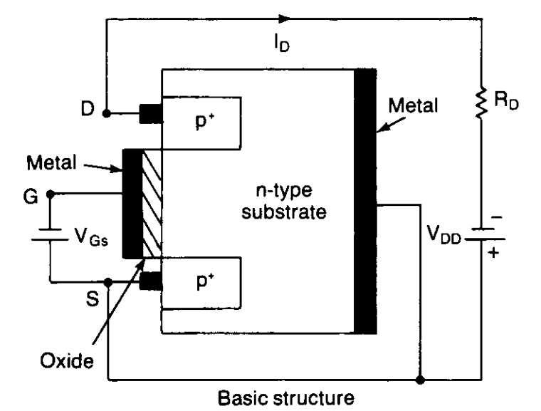

9) Reason of naming depletion type MOSFET.

Depletion-type MOSFETS are MOSFETs that are normally on. When we connect a depletion-type MOSFET, current flows from drain to source without any gate voltage applied. This is why it is called a normally on device. There is current flow even without a gate voltage. With a depletion-type MOSFET, maximum current flows from drain to source when no difference in voltage exists between the gate and source terminals (VGS=0).

In depletion type MOSFET the channel is diffused into the substrate. when we apply negative voltage to gate terminal of the MOSFET then the channel starts to deplete and eventually the MOSFET turns off. That’s why the name depletion type.

